Vocation Art Productions

Introduction at counterpoint
Polyphony was a genre that developmented itself in the Renaissance. It identify itself by tangled of voices.
Through of the law of the harmony that voices on put itself second a refined art of rule that appoint by counterpoint.
As a ballet, in that have voices in parallel, others at short distance, and others that go approaching or distancing symmetricaltly of the center of the stage. With help of the language and of the mathematicals concepts, also through of the geometry can to describe a few practices of counterpoint.

The looks of a melody
Sounds and noise is disturbions of the pression of the air picked by human ear. In a musical sounds, the disturbion is a regular variation that have a right frequency (height).
Ex: Sounds that have the same frequency and a certain lenght. At sucession of this sounds that happen without interruptions call melody.
So a melody as a function f (t) in that the frequency f depend of the time t.
Ex: A female voice and other male, in a choir, produce a pleasant sensation (accord).
And singing the same melody will have the function y = f(x) e y = 2f(x).
Look a few manners as the geometries transformations had a place in the structures looks musicals.

Notions of graphics of a function and hers fours mains families:
1 - Horizontals translations.
t : f(x) -> f(x-a)
a

2 - Verticals translations.
n : f(x) -> b+f(x)
b

3 - Horizontals reflections (=lake).
l : f(x) -> d-f(x)
d
4 - Verticals reflections (=wall).
m : f(x) -> f(c-x)
c
5 - Turns arounds (punctuals symmetris).
g : f(x) -> d-f(c-x)
c,d
www.vocationart.com 1

1-Horizontals translations:

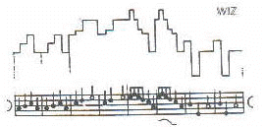
Traditional writing and graphic tune Fran Martino

2–Verticals and obliques translations:

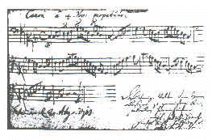
One autograph of J.S. Bach

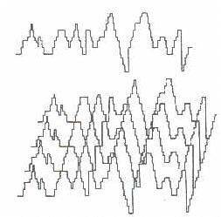
Graphic carrying of the cânone BMW 1073

www.vocationart.com 2

J.S.Bach: a few of the variations Goldberg

3–Reflections lake:

Effect of a reflection lake in the Fran Martino

www.vocationart.com 3
4-Reflections wall:

Effect of the reflection wall in the Fran Martino

5-Others transformation:

Effect of a turn around in Fran Martino

www.vocationart.com 4

